1.1 Use the Language of Algebra

List the first several multiples of 2

List the first several multiples of 3

List the first several numbers that are divisible by 2

List the first several numbers that are divisible by 3

How can you tell if a number is divisible by 2?

By 3?

By 5?

By 10?

By 6?
If , then a and b are factors of m

List all the factors of 12

List all the factors of 7

List all the factors of 9

A prime number has 2 factors, a composite number has more than 2. Which of the numbers above are prime and which are composite?

Is 91 prime or composite?

Composite numbers can be written uniquely as a product of prime factors, called their prime factorization. Find the prime factorization of 12, 7, and 9

Find the prime factorization of 224
Order of operations: PEMDAS

Simplify

Simplify

An expression is a number, a variable, or a combination of numbers and variables using operation symbols

3 + 5
n - 1
6 · 7

An equation is two expressions linked by an equal sign. When you read the words the symbols represent in an equation, you have a complete sentence in English. The equal sign gives the verb.

3 + 5 = 8
n - 1 = 14
6 · 7 = 42
x = 53
y + 9 = 2y - 3
To evaluate an expression means to find its value when a variable has a specific value.

Evaluate when x = 4:

x²

3^{x}

2x² + 3x + 8

Algebraic expressions are made of terms. A term is a constant or the product of a constant and one or more variables. Ex: 7, y 6x², 9a, -b⁵

The constant that is multiplied by the variable is called the coefficient

Identify the coefficient of the following terms
6x²

9a

y

-b⁵

When two terms have the same variable parts (with the same exponent), they are like terms.
We can combine like terms when they are added by adding the coefficients but keeping the variable part the same

Simplify
7 + 4

Simplify
5x + 3x

Simplify
n² + 9n²

Simplify
2x² + 3x + 7 + x² + 4x + 5

Translating an English Phrase to an Algebraic Expression
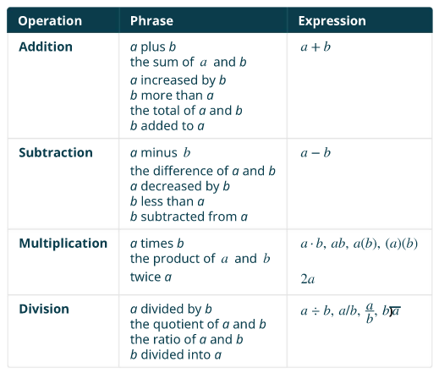
Translate each English phrase into an algebraic expression:

The difference of 14x and 9

The quotient of 8y² and 3

Twelve more than y

Seven less than 49x²

Since we don't have parentheses in English, we use the word order to indicate order

Eight times the sum of x and y

The sum of eight times x and y

The length of a rectangle is 14 less than the width. Let w represent the width of the rectangle. Write an expression for the length of the rectangle.

June has dimes and quarters in her purse. The number of dimes is seven less than four times the number of quarters. Let q represent the number of quarters. Write an expression for the number of dimes.
Section 1.2 - Integers

A negative number is a number that is less than 0. The negative numbers are to the left of 0 on the number line.

An opposite of a number is the same distance from zero, but on the other side of zero. The opposite of 2 is -2. The opposite of -2 is 2

The absolute value of a number is the number's distance from zero. The absolute value is indicated by vertical lines around the number.
Find the following

| 2 |

| -5 |

| 0 |

Inequalities indicate that a number is to the left or to the right of another number, for instance: -2 < 1 because -2 is to the left of 1 on the number line.

Use an inequality or equal sign to complete the following statements
| -5 | - | -5 |

8 - | -8 |

-9 - | -9 |

- ( -16 ) | -16 |

Simplify
24 - | 19 - 3(6 - 2) |

Section 1.3 - Fractions

A fraction is a way to represent parts of a whole. The fraction represents two of three equal parts.

The number on the top is called the numerator, and the number on the bottom is called the denominator

Fractions that have the same value are equivalent fractions. Equavalent fractions have the following property:

If a, b, and c are numbers where , , then and

A fraction is in lowest terms when there are no common factors of the numerator and denominator larger than 1, when simplifying you should put a fraction into lowest terms. If a number can be written as an integer, this is simpler than the equivalent fraction (eg: 13 instead of )

Simplify

Simplify

When you swap the numerator and denominator in a fraction, you get the original number's reciprocal.
Dividing by a number is the same as multiplying by its reciprocal.

The reciprocal of 2 is

Dividing by 2 is the same as multiplying by

This is true for fractions as well
Simplify

A complex fractions is a fraction where the numerator or denominator contain a fraction. It can be difficult to tell the order of operations here, so use longer division bars on the later divisions
Simplify , interpreting it as

Simplify , interpreting it as

Simplify (The middle division bar should be the longest)
Adding and Subtracting Fractions

If a, b, and c are numbers where c ≠ 0, then
and

The least common denominator (LCD) of two fractions is the smallest number that can be used as a common denominator of the fractions, and it is the least common multiple of their denominators.

Simplify

Simplify

Simplify

Combine into a single fraction

Section 1.4 - Decimals
Convert decimals, fractions, and percents
'Percent' is literally translated as 'divided by 100', so 3% is the same as

To translate from percent -> decimal, perform this division by 100 (moving the decimal places two places to the left)

To translate from decimal -> percent, move the decimal place the other way (to the right) as you add the percent symbol

Convert to decimal
3.16%

Convert to percent
1.23

Convert to decimal
163.673%

Convert to percent
732.646

To convert from fraction -> decimal, perform the division (usually on a calculator)
To convert from terminating decimal -> fraction, you can use the place value
To convert from a non-terminating decimal -> fraction, the rule is more complicated (use a calculator)

Convert to decimal, rounded to the thousandths place

Convert to a fraction in lowest terms
5.31
Square roots
There are two numbers that satisfy x² = 9, what are they?

The principle square root is indicated by the square root symbol, and is the positive one

Simplify

A rational number is a number that can be expressed as a ratio of two integers. Its decimal form either terminates or repeats.

6.3

1.012

1.5

An irrational number is a number that neither terminates nor repeats. There are several examples

π ≈ 3.14159265

1.23 223 2223 22223 ...

There are some numbers that don't even fit on the number line, which are called complex numbers

Two of the solutions of are not real (2i and -2i)

We'll discuss these later this semester
Section 1.5 - Properties of Real Numbers

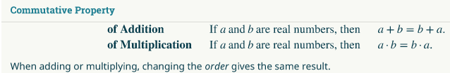
Simplify
2 + 3 + -2

Simplify

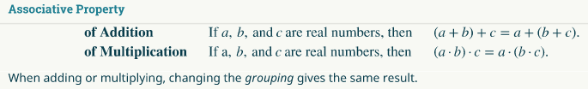

Simplify
3x + ( 4 + x)

Simplify
3x · (4 · x)
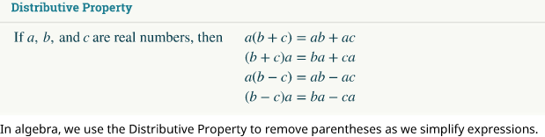
Simplify
3(x + 4)

Simplify

Simplify
100(0.3 + 0.25p)

Simplify
-11(4 - 3a)

Simplify
-(y + 5)

Simplify
8 - 2(x + 3)

